integricare-logo-rgb

Waiting List Application

CHrist church St Ives Preschool

Child’s Surname: First Name:

Date of Birth: Gender:

**Please indicate your preference by numbering 1 through to 4 (with 1 being your first preference):**

Monday/Tuesday Tuesday/Wednesday Monday/Wednesday Thursday/Friday

If additional days are available, would you be interested? Yes No

Which days: ____________________________________________________________________________________

When would you like to commence:

How did you hear about our service?

Does your child currently attend a Children’s Service? Yes No If yes, where?

**PARENT/GUARDIAN 1 PARENT/GUARDIAN 2**

Name Name

Relationship to child Relationship to child

Address Address

Suburb Suburb

Postcode Postcode

Email Email

Phone (Mob) Phone (Mob)

Phone (H) Phone (H)

Occupation Occupation

Language Spoken Language Spoken

at home at home

Is an interpreter or translation required for: Written English Spoken English

**Has your child had tests or reports done from any of the following services or is your child currently using any**

**of these services? Please tick.**

Medical Reports Vision Check

Basic Developmental Assessment Hearing Check

Psychological Assessment Special Education

Speech Pathology Special Play Group

Physiotherapy Respite Care

Occupational Therapy Using Disability Allowance

Do you have any concerns about your child’s development? Yes No

Please give details and attach copies of reports:

______

______

Year your child will attend school: ______

Integricare Preschools comply with the **Australian Government’s Priority of Access for Preschools** where a position is available,which targets**:**

* Children in their year before school, with the highest priority given to children closest to school entry (e.g. Children will generally be aged more than 3 ½ and less than 6 years)
* Children who are at risk
* Aboriginal and Torres Strait Islander children
* Children from low income families (i.e. those with Health Care Cards)
* Children from culturally and linguistically diverse backgrounds

**The NSW Government provides subsidy to assist with fees for families with a low income.** Do you hold either of these low income cards?

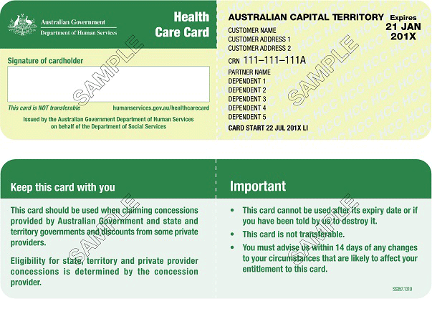

Yes No Yes No

If yes, please be aware that it will need to be sighted when lodging this form.

**Are there any other special circumstances or any cultural requirements relating to your child?**

Yes No Please give details: ______

______

______

______

I understand that if I fail to notify the Preschool of any changes to these details, I may forfeit my child’s place on the waiting list.

Parent/Guardian’s Signature: Date: ______

By completing this form your child’s name is added to our waiting list. If a place is offered and enrolment accepted, you will be required to pay the deposit, complete enrolment information and present your child’s original birth certificate or passport, and Immunisation History Statement for photocopying.

**Email: ccsi@integricare.org.au**

***The collection of personal information by Integricare is for the purposes of assessing your application for a position at an Integricare Service. If the relevant personal information requested in this form is not provided by you, we will be unable to assess your eligibility to access our service or your eligibility for any available childcare assistance support or funding that may be or become available.***

###### **OFFICE USE ONLY**

Priority of Access Category: 1 2 3 N/A

Date Application Received: …/…/… Booking Fee Paid: …/…/… Receipt No. ………………

Staff Name……………………..….… Staff Signature:………………………… Date: …/…/…

* Entered on Computer Date: …../……./……

**Child visited preschool? Y / N**

**Notes:**____________________________________________________________________________________________________________________________________________________

-

---