

STRATHFIELD PRESCHOOL Waiting List Application

Child’s Surname: |  |  |  |  |  |  |  |  |  |  | First Name:
Date of Birth: | / / |  |  |  |  |  |  |  |  |  | Gender: |  |  | M / F
Number of Days Per Week Required: |  |  |  |  | 2 Days  (Mon & Tues) |  |  |  |  |  |  | 2 Days  (Mon & Wed) |  |  | 2 Days  (Tues & Wed) |  |  | 2 Days  (Thurs & Fri)
Are these days flexible? |  | Yes |  | No |  |  | When would you like to commence? / /
How did you find out about our Service?
Does your child currently attend a Children’s Service? Yes / No If yes, where?

Parent/GUARDIAN 1 |  |  |  |  |  |  |  |  | Parent/GUARDIAN 2
Name |  |  |  |  |  |  |  |  | Name
Gender Male / Female Gender Male / Female
Address |  |  |  |  |  |  |  |  | Address
Post Code |  |  |  |  |  |  |  |  | Post Code
Email |  |  |  |  |  |  |  |  | Email
Phone (H) |  |  |  |  |  |  |  |  | Phone (H)
Phone (M) |  |  |  |  |  |  |  |  | Phone (M)
Occupation |  |  |  |  |  |  |  |  | Occupation
Place of  work/study |  |  |  |  |  |  |  |  | Place of work/study
Language Spoken |  |  |  |  |  |  |  |  | Language Spoken
Is an interpreter / translation required for: |  |  |  |  |  |  |  | Written |  |  |  |  |  |  | Spoken

Have tests or reports on the child been done from any of the following services, or is the child currently using any of these services? Please tick:

Medical Reports Vision Check
Basic Developmental Assessment Hearing check
Psychological Assessment Special Education
Speech Pathology Special Play Group
Physiotherapy Respite Care
Occupational Therapy Using disability allowance

Please give details and attach copies of reports: -
Integricare Sydney’s Preschools comply with the Australian Governments Priority of Access for Preschools where a position is available, which targets:
Children in their year before school, with the highest priority given to children closest to school entry (NB: Children will generally be aged more than 3 ½ and less than 6 years)
Children who are at risk
Aboriginal and Torres Strait Islander children
Children from low income families (ie those with Health Care Cards)
Children from culturally and linguistically diverse backgrounds

The NSW Government provides subsidy to assist with fees, for families with a low income. Do you hold either of these low-income cards?
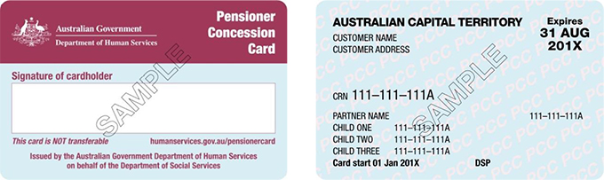
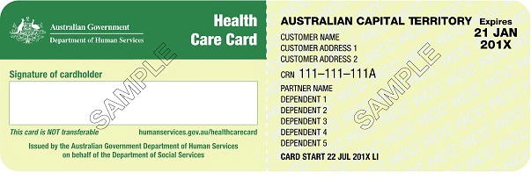

Yes No Yes No
If yes please be aware that it will need to be sighted when lodging this form.

Are there any other special circumstances or any cultural requirements relating to your child? Yes No

Please give details

I understand that if I fail to notify the Centre of any changes to these details, I may forfeit my child’s place on the waiting list.

Parent/ Guardian’s Signature: Date: / /

By filling in this form your child’s name goes onto a waiting list. There is no guarantee of placement in the Centre. If enrolment is accepted you will be required to complete an Enrolment Form, pay a non-refundable deposit, and present your child’s original birth certificate and Immunisation History Statement for photocopying.

Please make an appointment at the service to return the completed form. A waiting list fee will apply.
The collection of personal information by Integricare is for the purposes of assessing your application for a position at an Integricare service.
If the relevant personal information requested in this form is not provided by you, we will be unable to assess your eligibility to access our service or your eligibility for any available childcare assistance support or funding that may be, or become, available.

OFFICE USE ONLY
Priority of Access Category: 1 2 3 N/A

Date Application Received: …..../……../……… Application Fee Rec. No. ………

Staff Name…………………………Staff Signature:…………………………… Date: …../……./……
- Entered on Computer Date: …../……./……

Notes:__________________________________________________________________________________________________________________________________________________________________________________________________________

-

---

