**We are looking for the best of the best**

**Centre Manager**

**Full-time**

**Strathfield Preschool**

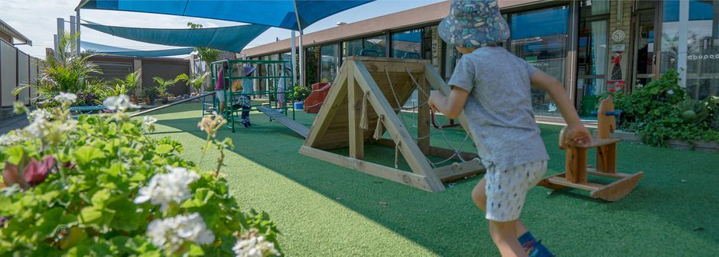

**Integricare is looking for a person with a strong passion for early learning to   
lead our team of professional educators at our Strathfield Preschool.**

**Integricare**

At Integricare we provide a rewarding environment for passionate people who are committed to seeing a new generation flourish. Established since 1882, as a Christian organisation, we have a long history of making a positive impact in communities. Our families tell us that our learning quality and care excellent, and in many cases exceptional. This does not happen by accident, we are only as good as our people, and we are looking for the best of the best.

**Strathfield  
Preschool**

Our team of dedicated educators look forward to a welcoming you to join them in making a positive impact to the local community. Find out more about our Preschool by visiting our website <https://integricare.org.au/strathfield/> .

**The Opportunity**

We are looking for a full-time Early Childhood Teacher Centre Manager to work 38 hours per week. Strathfield Preschool is a 45 place centre and operate for 41 weeks of the year.

It is essential that you have:

* Bachelor’s Degree in Early Childhood Education or ACECQA approved and recognised equivalent. Diploma trained with strong management experience will also be considered.
* A current Working with Children Check
* A current First Aid, Anaphylaxis and Asthma certification
* A commitment to the Christian ethos and values of Integricare, and a willingness to agree to our Christian Identity Statement.
* Sound understanding of Early Years Learning Framework, National Quality Standards and National Regulations
* A high level of written and oral communication skills between staff, families and wider community, including regulatory authorities
* Demonstrated ability to work independently
* Excellent organisational and time management skills including the ability to delegate and prioritise
* Current Child Protection Training
* Previous management experience desirable
* Proof of Covid Vax

You will need to demonstrate that you have a high level of expertise or experience in:

* Providing leadership and guidance to all staff in the day to day operation of the preschool.
* Conducting initiatives that promote team building and good working morale.
* Developing and maintaining the Centre Quality Improvement Plan and ensuring compliance in all aspects of the National Regulations.
* Management of the centre budget.
* Management of the physical environment including WHS and centre resources.
* Inspiring, motivating and maintaining a positive Christian learning culture for our families and educators.
* A commitment to building strong relationships with children, families and communities.
* Undertaking administrative tasks in the daily operation of the centre.
* Guiding a team of educators in the development and implementation of a high-quality educational program.
* Team leadership and educator engagement.

As an Integricare employee you receive the benefits of an organisation that provides:

* Above Award wages and Annual Leave loading
* Discounts on ELC fees
* Opportunities to learn and develop together within a community of over 200 employees
* Access to Employee Assistance Program (Confidential)
* Career opportunities and access to paid professional development and training
* Supportive managers and leaders who are committed to building an environment of excellence.

**APPLY NOW**

If this sounds like an opportunity too good to miss, then we would like to hear from you.

Please email your CV, with a covering letter addressing the requirement above to:

Donna Elvery **– Preschool Support Manager**

**delvery@integricare.org.au**

(Please note, only short-listed candidates will be contacted.)

**Integricare is committed to being a Child Safe organisation and   
adopts the National Principles for Child Safe Organisations.**

**Integricare is an equal opportunity employer**

**Integricare Centres are located in:**

**Rockdale Plaza . Brighton Le Sands . Rockdale . Turrella . North Strathfield .**

**Strathfield . Rozelle . St Ives . Northbridge . Pendle Hill . Parramatta . Northmead . Auburn**